A couple of people have been asking for this one. So here you go, Find Orphaned Files for Vault 2015.
Also, after my last app, I’ve been eager to post something that, you know, works.
Click here for a description of the app.
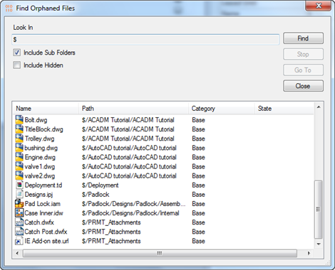

Requirements:
Vault Workgroup or Professional 2015
Click here to download the application
Click here to download the source code
Click here for the Vault 2014 version
As with all the samples on this site, the legal disclaimer applies.

